Design Document
RightQueue


Date : 04/09/2026
Version : 0.1
Status : Draft
Author : Hanh Ngo Minh Truong

1 Introduction
This document gives a comprehensive overview of the architecture and design of RightQueue, a multi-organization application that helps people send service requests to the appropriate team. It explains how the frontend, backend, and database work together, how responsibilities are divided, and how the data supports request routing. The purpose is to give developers, reviewers, and project assessors a clear reference for understanding the system and extending it consistently. The document summarizes the main decisions, explains the C4 and database diagrams, and identifies the principles that guide further development. Detailed technology comparisons and decision arguments are recorded separately in the Architecture Decision Record.

2 Architecture

2.1 Architecture constraints and decisions
RightQueue uses a modular monolith backend with a separate browser frontend and a shared relational database. This keeps development and testing manageable within a right level of complexity project while allowing authentication, organizations, the service catalogue, and requests to remain distinct modules. Changes involved in request submission can run in one transaction, without coordination between separate backend services.
The design must support several organizations without allowing their members to access one another's requests. The backend therefore checks active membership, roles, and related records.

2.2 Technology overview
• Backend: Django with Django REST Framework provides the Python application and JSON API. Views handle HTTP requests, serializers validate input, and a service function coordinates submission and initial routing. Django also supplies models, migrations, authentication, and administration.
• Frontend: React with TypeScript provides the browser interface. Reusable components display sign-in, organization information, service selection, and submission results. The frontend calls the API, while the backend remains responsible for permissions and workflow rules.
• Database: PostgreSQL is the relational database management system. It stores connected organization, membership, service, and request records. Foreign keys, unique constraints, and transactions help maintain consistent data; Django's ORM provides application access.
The main supporting principles are separation of concerns, single responsibility, and reuse of shared behavior. They keep interface code, validation, and workflow logic understandable without adding unnecessary layers.
For more details, refer to the Architecture Decision Records document.

3 C4 model overview
The C4 views move from RightQueue's users and external relationships to its containers and internal backend responsibilities. The supplied diagrams describe both the current foundation and the intended wider design. Planned features are identified below so that the design is not confused with completed functionality.

3.1 System Context Level 1
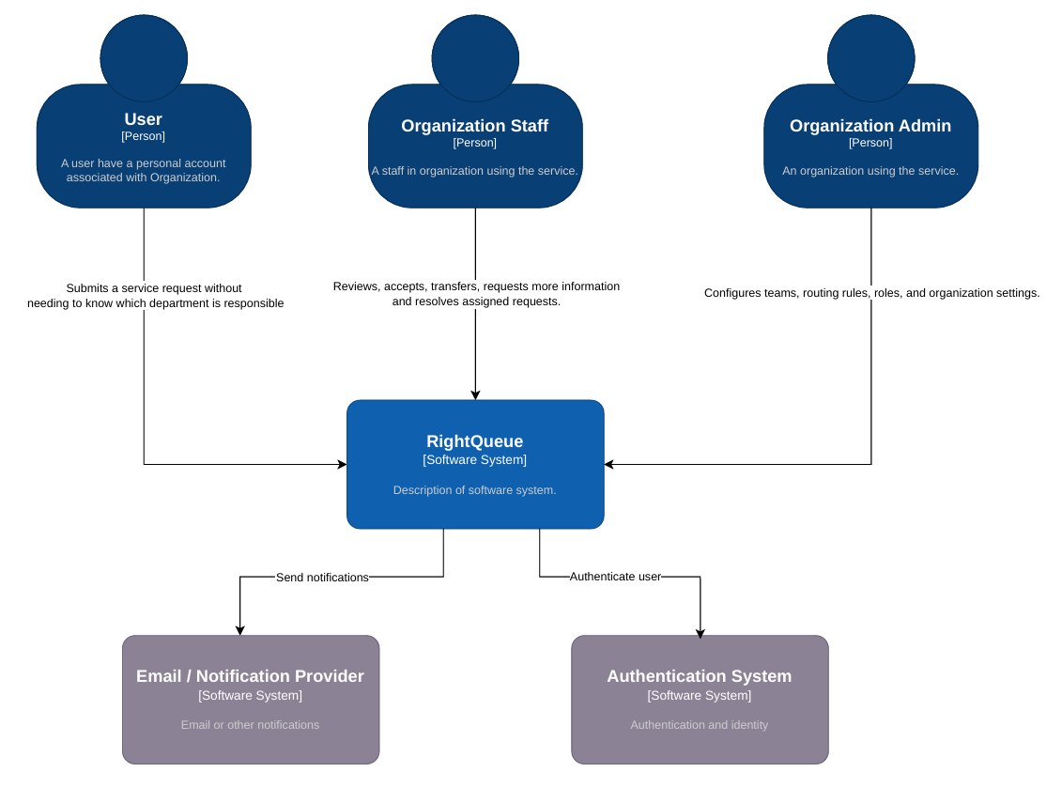
C1 Diagram represents three user groups and two external systems. Their responsibilities are:
• User: A person with an account associated with an organization who submits a service request without needing to know the responsible department.
• Organization Staff: Staff who are intended to review, accept, transfer, request more information, and resolve requests. Complete handling workflows remain planned.
• Organization Admin: An administrator responsible for teams, roles, routing configuration, and organization settings. Current maintenance uses trusted Django Admin access; organization-scoped administration remains planned.
• RightQueue: The central system that receives requests, identifies an initial destination, and keeps request state and history within an organization.
• Email / Notification Provider: A proposed external service for notifying users about request activity. No provider integration is implemented in the current MVP.
• Authentication System: An external identity service shown in the target context. Current sign-in is handled inside Django through local credentials and sessions; institutional single sign-on is outside the MVP.
Triage coordinators are not drawn separately in C1. The application defines their role for future review and reassignment of uncertain requests within an organization.

3.2 Container Diagram Level 2
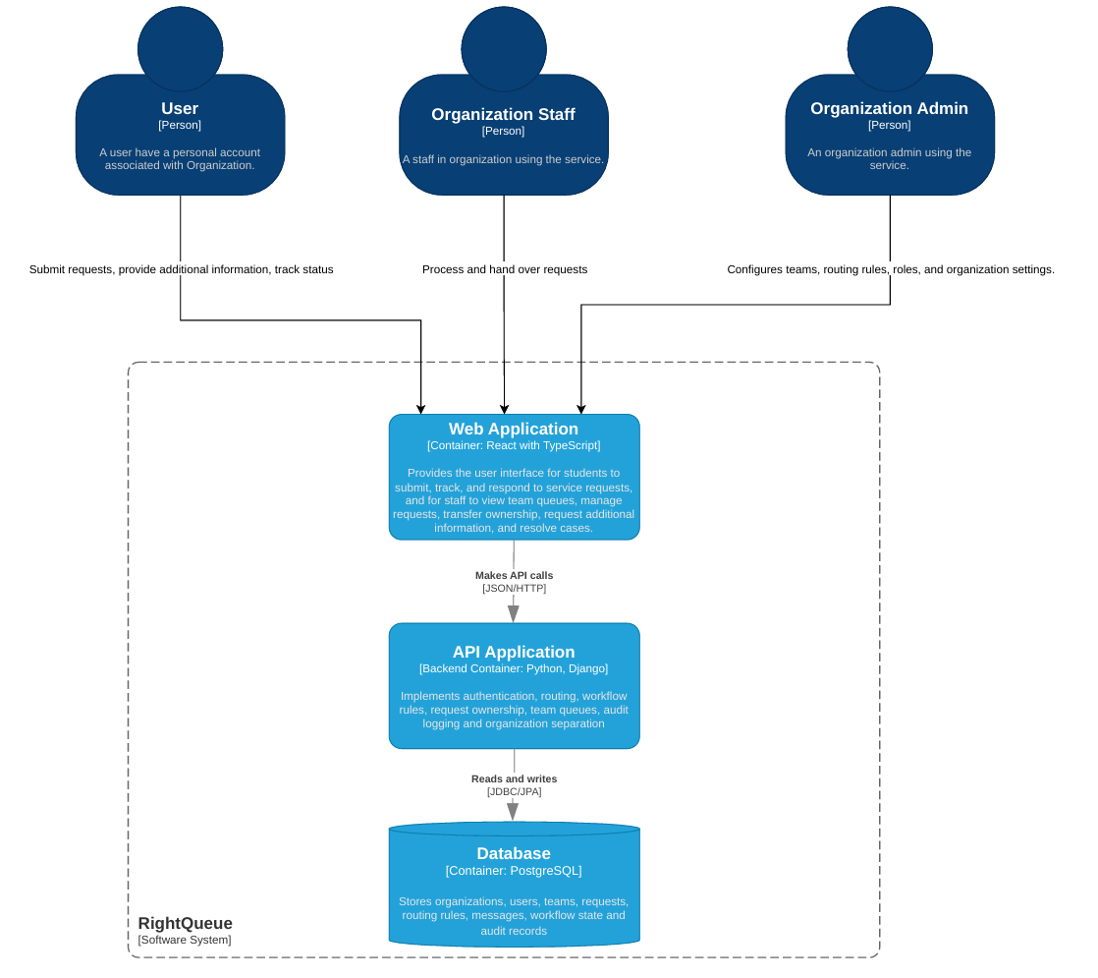
The diagram divides the system into three containers. A container here means a running application or data store, rather than necessarily a Docker container.
• Web Application: React with TypeScript presents the user interface. Submission is implemented; tracking, requester replies, staff queues, and handover describe the intended expansion.
• API Application: The Python and Django backend authenticates users, validates input, checks organization access, and performs initial routing. It provides the foundation for later workflow and ownership operations.
• Database: PostgreSQL stores the current organization, account, team, service, request, and status-history data. Messages and separate routing-rule records mentioned in the diagram are not present in the current schema.
The browser exchanges JSON with the API over HTTP. The backend reads and writes PostgreSQL through Django's ORM and the Psycopg driver. The JDBC/JPA label in C2 refers to Java technologies and should be understood as Django ORM database access in this project. The frontend does not connect directly to the database.

3.3 Component Diagram Level 3
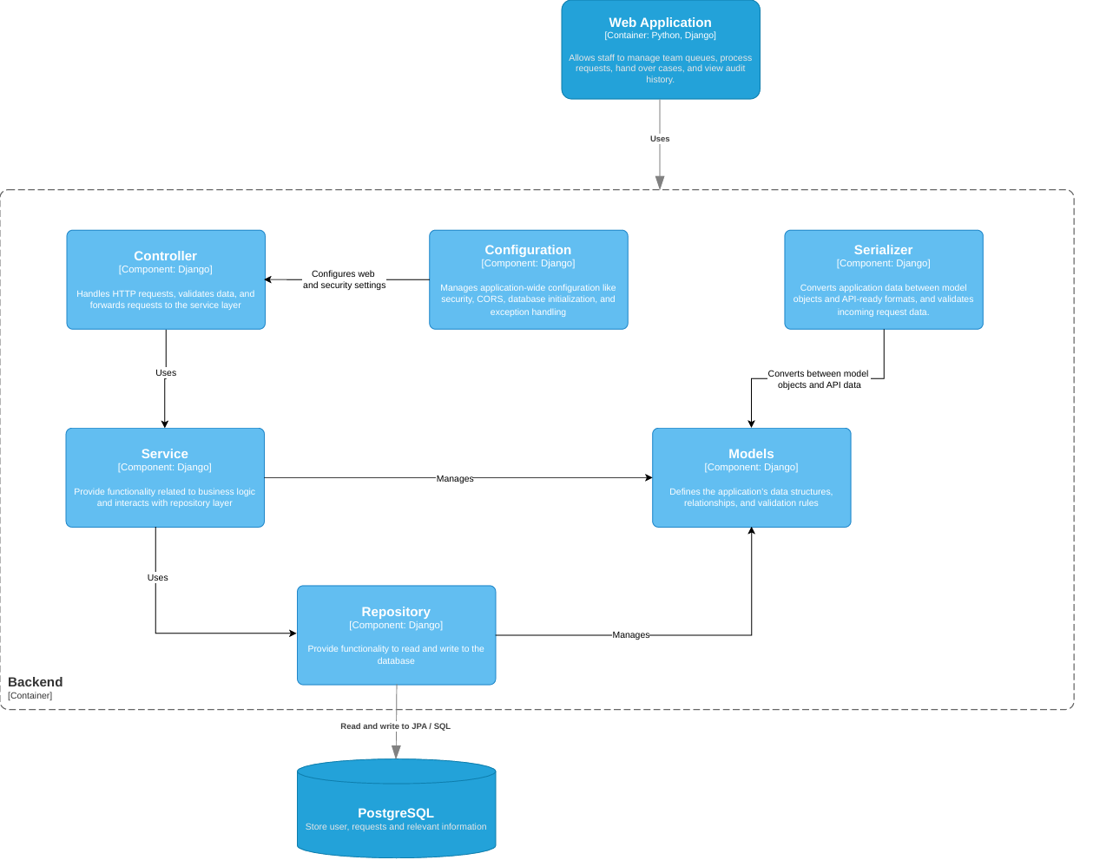
C3 diagram focuses on responsibilities inside the backend. Its Controller, Service, Repository, Serializer, Models, and Configuration boxes describe a logical separation. They are implemented within one Django application, not deployed as independent services.
• Controller: Django REST Framework views receive HTTP requests and return responses. In RightQueue they handle authentication endpoints, service catalogue access, and request creation. They check access, use serializers for input, and call the submission service when business coordination is needed.
• Serializer: Serializers validate incoming fields and convert application objects into API responses. For example, request creation validates the title, description, and optional service, while the response exposes the reference, destination, and current status.
• Service: The submission service contains the business sequence: check membership and requester role, create the request, determine its initial destination, and record status history. This keeps the workflow separate from HTTP response handling.
• Repository: This box represents data access. The current code uses Django model managers and querysets directly rather than custom repository classes. Django's ORM translates these operations into database queries.
• Models: Model classes define organizations, memberships, roles, services, teams, requests, and status history. They describe relationships and validation rules, including checks that related records belong to the same organization.
• Configuration: Django settings and URL configuration establish application modules, endpoints, authentication, middleware, browser-origin rules, and database connectivity. Database structure is created and changed through migrations rather than by the configuration component itself.
The Web Application outside the backend boundary is the calling browser frontend. Its Python/Django label in C3 conflicts with C2 and the code: the frontend is React with TypeScript. PostgreSQL is the external data store; the JPA/SQL connection label represents ORM-generated SQL through Psycopg, not a Java persistence layer.

Request submission workflow example
A requester sends a title, description, and optional service from the frontend. The view checks organization membership and the serializer validates the payload. The service then checks the requester role and writes a SUBMITTED history event. If the selected active service has an active default team, it assigns that team and sets QUEUED. Otherwise, including when no service is chosen, it sets PENDING_TRIAGE. The request and its two initial history events are saved in one transaction, so a failure rolls back the whole operation.
This illustrates the intended responsibility split without suggesting that every endpoint must pass through every component. Simple catalogue reads currently use the ORM directly from the view.

4 Database design overview
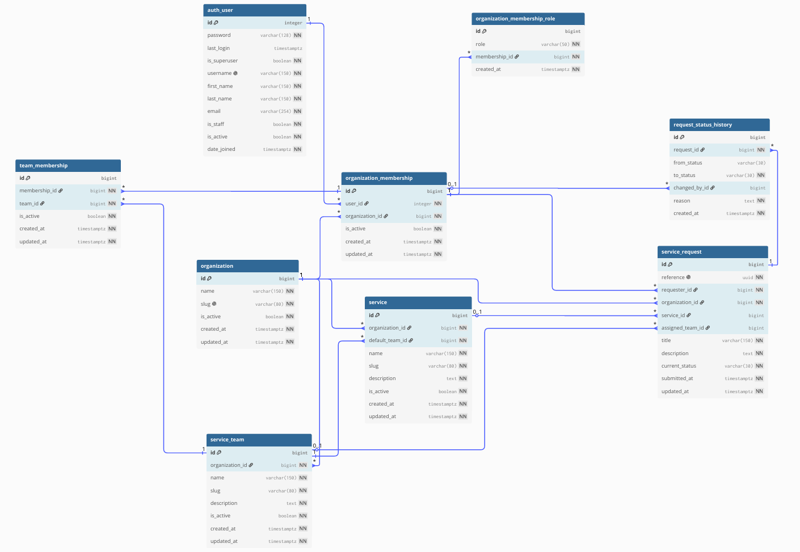
The database diagram shows a relational design centered on organizations and their memberships. It separates a person's account from their organization-specific access, then connects services and teams to the requests they receive. This structure supports several organizations in one database while preserving explicit ownership of each business record.

4.1 Main tables
• auth_user: Stores the Django account, including username, hashed password, account details, and global administration flags. Django's is_staff flag is separate from the RightQueue STAFF role.
• organization: Defines an organization through its name, unique slug, active state, and timestamps.
• organization_membership: Links one user to one organization and records whether that membership is active. A user may have memberships in several organizations.
• organization_membership_role: Assigns roles to a membership. Separate rows allow the same member to be both a requester and a staff member without applying those roles to every organization.
• service_team: Defines a team belonging to an organization and records whether it is active.
• service: Describes an available service and its required default team. This relationship provides the current automatic routing rule.
• team_membership: Links an organization membership to a team. It supports several members per team and several teams per member, with an active flag for each link.
• service_request: Stores the request reference, title, description, organization, requester membership, optional service, optional assigned team, current status, and timestamps.
• request_status_history: Records a request's previous and new status, the actor membership when available, a reason, and the event time. System-generated routing uses a null actor.

4.2 Relationships and integrity
An organization has many memberships, teams, services, and requests. Each request belongs to one organization and one requester membership, while one request can have many history entries. Optional service and team links allow an uncertain request to exist before a coordinator chooses its destination. The requester link points to an organization membership rather than directly to the global account, preserving the organizational context.
Unique constraints prevent duplicate user-organization memberships, repeated roles on a membership, and duplicate team memberships. Service and team names and slugs are unique within their organization. Foreign keys protect relationships, while model validation and backend access checks enforce organization consistency; foreign keys alone do not provide organization isolation.
Keeping history separate makes the current request easy to retrieve while retaining earlier status changes. Transactions keep initial request state and history consistent. This is a foundation for auditing, not an immutable audit store: privileged administrators can edit history, and deleting a request also removes its history. The current schema does not contain separate message or configurable routing-rule tables.

5 Design principles
RightQueue will follow five practical principles to keep the system understandable, maintainable, and safe to extend. The existing implementation provides examples of each, while further workflows should apply them consistently.

5.1 Single responsibility and separation of concerns
Each module should focus on one area: accounts handles sign-in, organizations handles membership and roles, service_catalogue handles services and teams, and cases handles requests. Within those modules, views manage HTTP interaction, serializers validate API data, and service functions coordinate workflows. React components focus on presentation. This applies the Single Responsibility Principle from SOLID and helps changes remain local to the part that owns them.

5.2 Object-oriented modeling and encapsulation
Django models represent domain concepts as classes with fields, relationships, and validation behavior. Related rules should stay close to the concept they protect, such as checking that a service and its default team share an organization. Multi-record workflows belong in focused service functions. Existing framework classes should be reused where helpful, without introducing inheritance or abstract layers that the project does not need.

5.3 Do not repeat yourself
Shared behavior should have one maintained implementation. The frontend API client handles common request and CSRF behavior, while reusable components keep the interface consistent. The backend submission service centralizes initial routing and history creation. New features should reuse these functions where appropriate. Frontend validation may repeat a server check to improve feedback, but the server must always enforce the rule independently.

5.4 Least privilege and explicit authorization
Access should be granted only for the operation and organization a user is allowed to use. Current submission checks authentication, active membership, and the requester role. Future staff operations must also check relevant team membership, and triage actions must check the coordinator role. A visible button or a known record ID never grants permission. Trusted Django Admin access must remain separate until organization-scoped administration is implemented.

5.5 Data integrity and atomic operations
Related changes should succeed or fail together. Request submission already uses a transaction to save the request and initial history as one operation. Unique constraints, foreign keys, and explicit validation provide complementary checks. Future handover and status changes should follow the same pattern and include tests for rollback and unauthorized access. This prevents a request's visible state from disagreeing with its recorded history.
These principles support the existing modular design without claiming full SOLID compliance. In particular, the service currently depends directly on Django models, so a separate dependency-inversion or custom repository architecture is not implemented.

